|  |  |
| --- | --- |
|  | |
|  | The Little Driver – Heated Bed Power Module. An optically isolated power switch for heated beds and other heater loads in 3D printers. |

Theory of Operation 2

Using The Trigger 2

Over Driving Your Heated Bed 3

Wire Sizing 3

Installation 4

Mounting the board 4

Controlling from an Existing Heated Bed 4

Controlling from an CPU digital output 4

Trouble Shooting Guide 4

FET is getting HOT very HOT 4

Light does not turn on 4

Light is on but the bed does not get hot 4

Light is on all the time 4

# Theory of Operation

## Using The Trigger

The little driver uses and optically isolated transistor to turn on the MOSFET. This allows the MOSFET to be turned on in a verity of ways. It also allows the Heated BED to operate at a different voltage than the main control board.

When the trigger on the little driver supplied with 5mA the output MOSFET will turn on.

The circuit below is a model of how the little driver works.

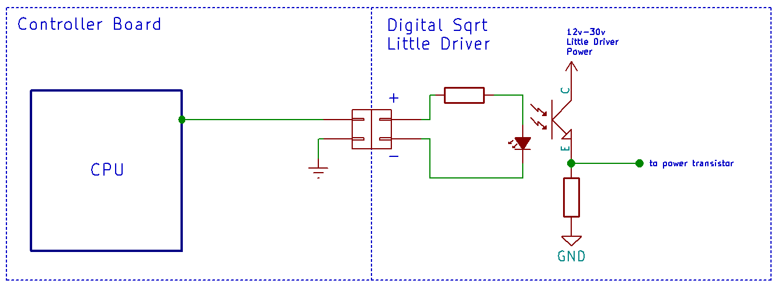

R3

I1

Q1

R2

Notes: The output power MOSFET is not shown in this diagram. The LED and Q1 are in an IC on the board. This LED is not the indicator LED.

There are some things that are worth mentioning about this circuit. The Ground (or reference) is not the same ground as on the Little Driver. In this example both devices are powered by a completely different power supply. For example. Your main control board my only be designed for 12v. But you want to use a 24V 20A heated bed. The little driver is perfect for that situation.

The LED biases transistor Q1; forcing it to conduct. All that is necessary is to make the LED light up.

Circuit example: The LED’s forward voltage is 1.4v or less. The CPU logic is 3v. We set R3 to 300 ohms Voltage across R3 = 3 - 1.4. I1 =VR3 / 300 = 5mA. For a 5v CPU I1 = 5 – 1.4 / 300 = 12mA.

Once Q1 is conducting the voltage across R2 turns on the Power MOSFET. It also acts as a charge bleed off resistor when Q1 is off.

It is also possible to us the main control board supply as the supply for the little driver. The control board and the Little driver would share a ground. This does not change the operation. Then the heated bed, Little Driver board, and Your Control board must be rated to use the same voltage.

***Using The Trigger (continued)***

Having 2 power supplies is not the only reason for optical isolation. The trigger can be used in another configuration.

Consider the configuration below.

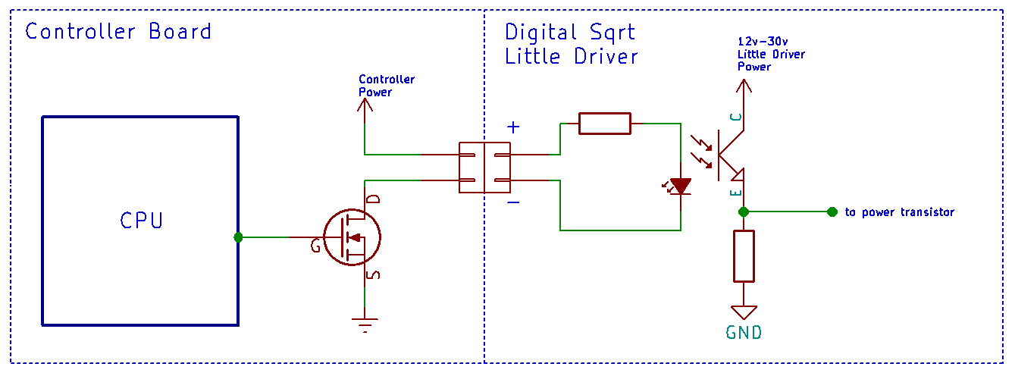

R3

I1

Q1

R2

Basically, instead of the heated bed being the load on the controller board; the Little Driver’s trigger circuit is. **Most users will be using this configuration.**

The calculations are very similar the previous configuration. Some assumptions will need to be made. We will assume that the voltage drop across the controller boards MOSFET is 0V. Also assuming that the controller’s power supply is 12v and R3 is 1.99K. Then I1 = (12v – 1.4v)/1.99K = 5.3mA. If the supply voltage was 24v then we would have I1 = (24v – 1.4v)/1.99K = 11.4mA.

Remember, 5mA is the minimum required current to get the power MOSFET to turn on. At 30mA the part has a premature death.

If you noticed we did just change the value of R3 from the previous example. When JP1is installed on the Little Driver R3 is 300 ohms. When it is removed; R3 is 1.99K.

**An important note. If this configuration is used and JP1 is installed you will destroy the Little Driver’s opto-isolator.**

## Over Driving Your Heated Bed

## Wire Sizing

# Installation

## Mounting the board

#### Mounting to 1515 or 2020 Aluminum Extrusion

#### Other Mounting Options

## Controlling from an Existing Heated Bed

## Controlling from an CPU digital output

# Trouble Shooting Guide

## FET is getting HOT very HOT

## Light does not turn on

## Light is on but the bed does not get hot

## Light is on all the time